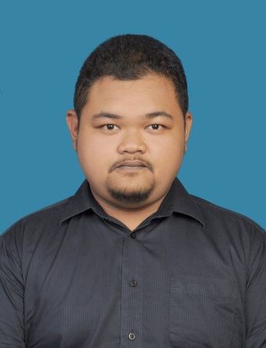PERSONAL INFORMATION

Name: MUHAMMAD ALIFF BIN ABDULAH

Address: 68, JALAN 12, TAMAN HARMONI KAJANG,

43500 SEMENYIH, SELANGOR

Telephone number: 012-6980413

E-mail Address: [muhdaliff589@gmail.com](mailto:muhdaliff589@gmail.com)

EMPLOYMENT OBJECTIVE

I am seeking a company where I can use my experience and education to help the company meet and surpass its goals.

EDUCATIONAL QUALIFICATION

2012-2016 : Bachelor of Electronic Engineering Technology (Telecommunications) Universiti Teknikal Malaysia Melaka,

Melaka

2009-2012 : Diploma of Electronic and Electric Engineering Politeknik Sultan Abdul Aziz Shah, Shah Alam

2007-2008 : SPM in Electrical and Electonic Engineering Sekolah Menengah Teknik Bukit Piatu, Melaka

WORK EXPERIENCE

January-June 2011 : Technician with Service Master (M) Sdn, Bhd.

June-September 2012 : Cashier with Petronas. Sdn. Bhd.

Febuary-August 2016 : Practical with Telekom Malaysia Sdn. Bhd

August-October 2016 : Working as Supervisor at Musim Kasturi Sdn. Bhd

ACHIEVEMENT

* 3 month PLKN at Kem Mantin, Negeri Sembilan in 2008
* Participate in Pertandingan Badminton, Sukan dan Rekreasi IEM-UTeM 2014

SKILL

* Excellent in malay and moderate in English which are writing and speaking.
* Excellent in used Microsoft office
* Excellent in working in a team and fast leaner.
* I have an experience in fiber telecommunication network

REFERENCE

Name: Norfadzlia Binti Mohd Yusof

Telephone Number: 06-2346436

E-mail: norfadzlia@utem.edu.my

Name: Md Ashadi Bin Md Johari

Telephone Number: 06-2346813

E-mail: ashadi@utem.edu.my